EXPERIMENT 1
TITLE: DEFORMATION OF SOLID BODIES
AIM: to measure the deformation caused by the weight of ‘mass pieces’ on two helical springs.
APPARATUS: support base, support rod, double clamp, weight holder (10g), slotted weight (10g and 50g), helical spring (3 ), holding pin, glass tube holder, measuring tape (2m).
METHOD
- A stand with the support rod and the double clamp was set up. The holding pin was fixed in the double clamp and a 3 N/m helical spring was hanged on it. A glass tube holder was clamped on the base of the support rod in which the extended measuring tape was clamped. The length of the measuring tape was adjusted such that its zero mark was exactly at the same level as the lower end of the helical spring. A weight holder (m=10g) was hanged on the hooked end of the helical spring and the extension Δl was recorded. The mass was increased by 10g increments to a total of 50g and the corresponding extensions Δl was read. All the values of the mass m and the extension Δl were recorded as in the table below.

- A 20 N/m helical spring was hanged on the holding pin and the measuring tape was adjusted until its zero mark was even with the lower end of the spring. The weight holder with a 10g mass piece (sum = 20) was hanged on the spring’s hook and the extension Δl was recorded. The mass was increased in 20g increments up to a total of 200g and the corresponding extensions in length were determined. These values were also recorded in a table below;
TABLE OF RESULTS (observation)
1. Helical spring used- 3N/m
MASS m/g | WEIGHT Fg/N | DEFLECTION Δl/cm
10.0 | 0.1 | 3.0
20.0 | 0.2 | 5.8
30.0 | 0.3 | 8.8
40.0 | 0.4 | 11.9
50.0 | 0.5g | 14.8

2. Helical spring used -20N/m
Mass m/g | WEIGHT Fg/N | DEFLECTION Δl/cm
20.0 | 0.2 | 1.0
40.0 | 0.4 | 2.0
60.0 | 0.6 | 3.0
80.0 | 0.8 | 4.0
100.0 | 1.0 | 4.8
120.0 | 1.2 | 5.8
140.0 | 1.4 | 7.0
160.0 | 1.6 | 7.9
180.0 | 1.8 | 8.9
200.0 | 2.0 | 10.1

DISCUSSIONS

CALCULATIONS

SOURCES OF ERROR
- .
PRECAUTIONS

CONCLUSION

PHYSICS PRACTICALS, EXPERIMENT 3 20/03/2009
SM/SMS/08/0011 Karikari Appau Kyerewaa Bernice
TITLE: VIBRATION OF SPRINGS
AIM: To measure the frequency of a spring at a fixed tension (20N) and varying the length.
APPARATUS: Nickel wire (d=0.3mm, l=100m), rod with hook, striking hammer, oscilloscope (30MHz, 2 channels),metre rule(0.1cm), lamp bulb(6v/3w),digital counter, screen cables, connector T type.
DIAGRAM
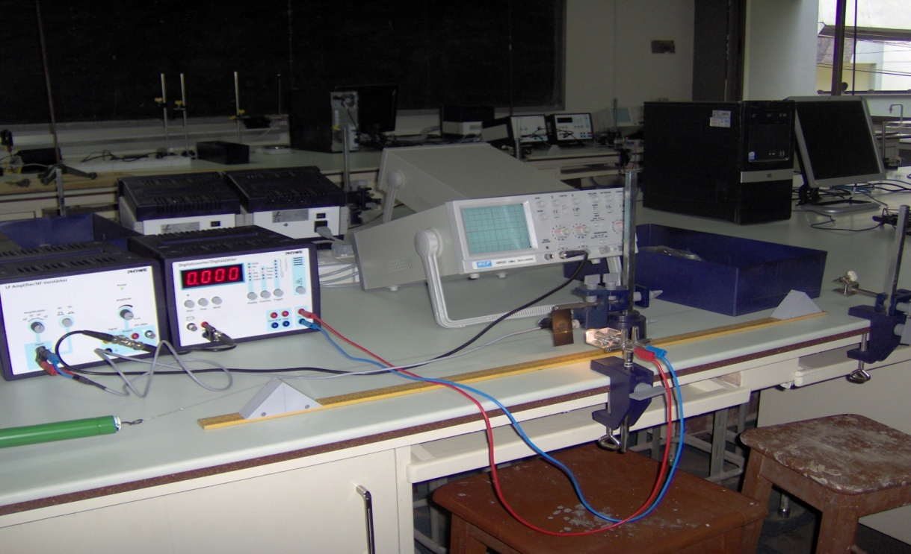
Digital counter
Rod with hook
Oscilloscope
Triangular sliders
Bench clamp
Blue connection wire
Red connecting wire
THEORY
Nickel wire
Meter rule

THOERY
An interference (combination of separate waves in same region of space to produce a resultant wave) effect that can occur when two waves overlap is called a standing wave. In any case the principle of linear superposition which states when two waves interfere the resultant wave function at any point is the algebraic sum of the individual wave functions) provides an explanation of the effect of standing waves. Frequency is the number of waves passing an area per unit second. For a periodic wave, frequency is the rate at which the disturbance is repeated. Fundamental frequency is the lowest frequency corresponding to n=1 and is produced by the first harmonic. The fundamental wave pattern is a transverse standing wave pattern. A standing wave does not travel in one direction or the other as do the individual. The fundamental frequency is produced by plucking the string gently in the middle which sets up the simplest stationary wave. A displacement node is obtained at each ends of the string because these points cannot move, and displacement antinodes are obtained in the middle where the string is most free to move. Nodes are places that do not vibrate at all and antinodes are places of maximum vibrations. As tension increase the frequency of the normal modes increase. The normal modes are also inversely proportional to (vibrating) string length. Tension is not affected by the pulse. The frequencies of stringed instruments can be changed either by varying the string’s tension, , or by changing its length , . When a stretched string is distorted to a shape that corresponds to any one of the harmonics after being released, it will vibrate at the frequency of the harmonic. However, if the string is plucked or bowed, the resulting vibration will include frequency of the various harmonics, including the fundamental. The frequencies above the fundamental are overtones. Standing waves arise because identical waves travel on the string in opposite direction and combine in accord with the principle of linear supper position the speed of a wave in a medium depends on the nature of the materials of the medium. Frequency of the modes is the integral multiples of the fundamental frequency. The higher natural frequencies together with the fundamental frequency form a harmonic series. Suppose a string of length l as in our experiment with tension T, and vibrated at a frequency f,

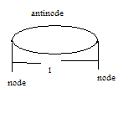This means that the distance from node, N to subsequent node, N is . The speed of the wave passing through the string is where the fundamental frequency. From or the speed of a wave in a string is related to the tension in the string and the mass per unit length of the string as
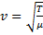 . Therefore, 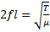 and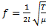. It follows therefore that the frequency of a vibrating string is directly proportional to the square root of the tension in the string. For the same string the pitch of the note increases with increase in the tension applied between its ends for the same length. If 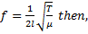 a graph of against has a slope equal to .

METHOD
The string was laid across two triangular sliders and clamped between a fixed hook and a spring balance. The spring balance was attached to a tensioner with fishing line. Keeping the tension in the string constant at 20N, the length 40cm of the string was measured by moving the triangular sliders along the scale. The counter/timer device was set to frequency (KHz). The diameter of the wire was then recorded. The sensor was aligned to the string and light so that the counter read zero. The start button was then pressed. The wire was then gently tapped with the rubber hammer to start the vibrations. The stop button was pressed when the harmonics had died away (frequency was stable) and the frequency was recorded. The experiment was repeated for four other values of l= 50, 60, 70, 80cm. A graph of against was plotted. The slope of the graph was the determined and also the mass per unit length and the density of the string.

TABLE OF RESULTS (observation)
String used: Nickel wire
Diameter of string: 0.3mm
Tension in the string used: 20N

Length,/cm
40.0 | 0.4 | 2.500 | 232 | 232 | 232
50.0 | 0.5 | 2.000 | 186 | 186 | 186
60.0 | 0.6 | 1.667 | 155 | 155 | 155
70.0 | 0.7 | 1.429 | 132 | 132 | 132
80.0 | 0.8 | 1.250 | 116 | 116 | 116

GRAPH
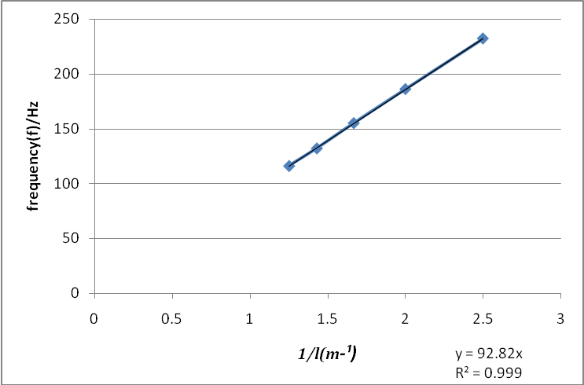A

CALCULATIONS
From the graph, 92.82 this means
- s similar to y=mx–c where m=92.82= slope and
Therefore the slope of the graph is 92.82
- From 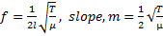 Squaring both sides, m² = ( )² m² =

...............................1
Slope,

- but the wire is treated as a cylinder
Where r=radius of the cylinder=
Height of the wire,
But
Where
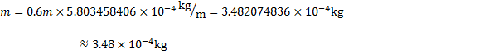
Therefore,

DISCUSSION
The experiment was performed on a vibrating string to measure the frequency of a string at a fixed tension of 20N and varying the length. At the end of the experiment, a straight line was obtained when the frequency (Hz) was plotted against the reciprocal of the length (m⁻¹). This proves that indeed that frequency is inversely proportional to the length. Thus as the values for the frequency increased, that of the length decreased. For instance, when the length of the wire was adjusted 0.40m the frequency on the counter read 232Hz whereas when the length was increased to 0.60m, the frequency then changed to 115Hz. The slope of the graph was determined to be 92.82 and it was used to calculate the mass per unit length of the nickel wire which was also found to be . It was also used to determine the density of the nickel wire and the value obtained was Comparing this obtained value to the theoretical value which is 8900, it is seen that a slight deviation. This deviation of about 693 this deviation could be attributed to sources of error that could have influenced the accuracy of the experiment carried out. Most importantly, one should consider the fact in the theoretical determination of the density of nickel, a wire with a small diameter of 0.3mm would not be used. Hence, in our experiment it is not surprising that an approximate value was acquired. It is therefore very wise to say that the frequency of a string at constant tension decreases as the length increases. That is frequency is inversely proportional to length. Also from the graph plotted of f against produced a straight line showing strong correlation with a gradient of 92.82. This means that once the tension is fixed with an increasing length, the frequency also increases constantly.
SOURCES OF ERROR
- Error might have been caused by the improper calibration of the meter rule that was used to measure the length of the string. The recorded value of the length string (that is 60cm) might not be the actual length.
- There might be some parallax error in the measurement of the length of the string.
- It is possible that the calibration of the spring balance and other apparatuses such as the counter/timer used were not properly calibrated and therefore resulted in errors in one way or the other.
- The string vibrated at its natural frequency which added some hertz to the frequency measured by counter
PRECAUTIONS
- It was ensured that the tension did not exceed 30N in order to prevent the string from breaking.
- The experiment was repeated in order to avoid random error.
- The counter/timer was only started when the harmonics had died away in order to record the frequency only when it became stable and to ensure accuracy.
- The triangular sliders were well fixed in so that they would not slip in the course of the experiment that was done to eliminate errors.

CONCLUSION
The slope of the graph. The mass per unit length of the spring µ was calculated to be approximately equal tohe density of the wire ρ is therefore equal to

CelestinOsei-Boateng SM/SMS/08/0031 EXPERIMENT 8
TITLE: REFRACTION OF LIGHT
AIM: To determine the refractive index of a glass block using Snell’s law.
APPARATUS: glass block, 4 optical pins, protractor (), drawing paper, a pair of compass.
DIAGRAM
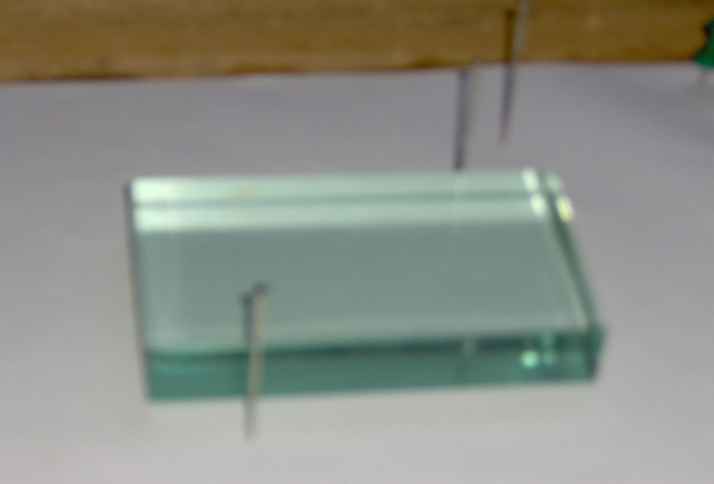
Optical pin
Glass block

THEORY
Refraction is the change in the direction of light ray as it goes from one material to another. When a ray PA is incident in air on the air-glass boundary, it is refracted towards the normal NAN when it enters the glass (Fig. 1).some of the light is also reflected at A along AS but AS is a weak ray compared with the refracted ray. The ray AB in glass is also refracted at the glass-air boundary along BQ in air, away from the normal at B.

incident ray N reflected ray

A B
Refracted ray O

D B C
Fig. 1
Emergent ray
From Snells law n (refractive index)
Where are the angle of incidence and angle of refraction respectively. From the diagram
But n so n
PROCEDURE
The glass block was placed on the white sheet of paper pinned to the drawing board. The edges of the glass block were traced on the drawing sheet and it corners labelled ABCD. The normal NOM was drawn. The angle of incidence was drawn and two pins P₁ and P₂ were pushed into the paper along the line to represent the incident ray. The glass block was carefully replaced on the paper. The images of P₁ and P₂ were found by looking through the glass block along the side CD. While looking, two pins P₄ and P₃ were pushed on the drawing sheet so that they were in a straight line with the images of P₁ and P₂.the glass block was removed and the points P₃ and P₄ joined with a straight line. The line was produced to meet the side CD at Z. This is the emergent ray. Z and O (the point of mergence and the point of incidence) were joined. This represented the refracted ray. With centre O and a suitable radius, a circle cutting through the incident and the refracted ray at R and Q respectively was drawn. With set square perpendiculars RP and QS was drawn unto the normal NOM.RP, QS and the angle of refraction were measured and recorded. The experiment was repeated for angle of incidence

TABLE OF RESULTS
20 | 13 | 0.2309 | 0.9 | 0.6 | 1.4
40 | 26 | 0.4877 | 1.8 | 1.1 | 3.0
50 | 30 | 0.5774 | 2.1 | 1.3 | 3.7
60 | 36 | 0.7265 | 2.5 | 1.5 | 4.5
70 | 38 | 0.7813 | 2.8 | 1.6 | 4.9

GRAPH
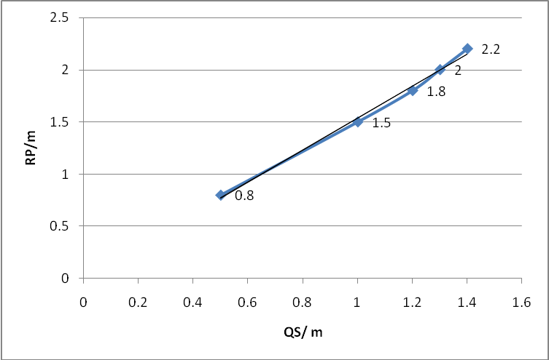 Y=1.536x Fig.1

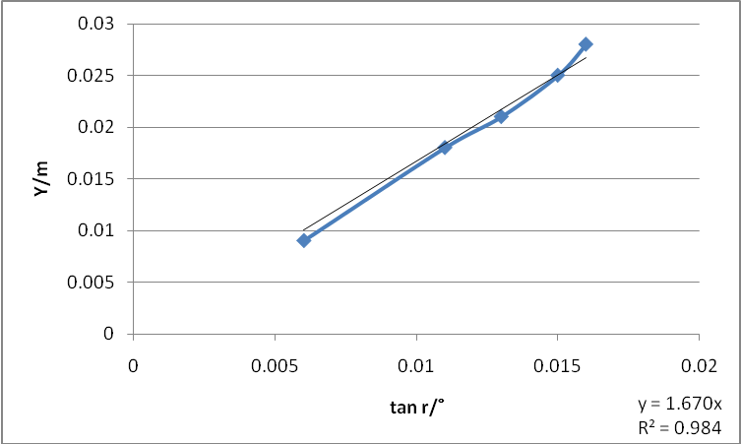 Fig.2

CALCULATION
(1)Comparing the equation of the graph1.536x to y=mx+c, the slope was found to be 1.536. This value represents the refractive index of the glass block.
(2)The slope of Y against tan rº was found on the graph above to be 1.670m.
(3)
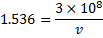
=
DISCUSSION
The experiment was conducted to determine the refractive index. As seen in fig. 1 and 2 the two graphs are straight lines. From the
In this experiment the index of refraction of the glass block was found to be 1.538. This value gives a measure of the bending of light when it travelled from air through the glass. But the theoretical value for refractive index is 1.52, which differs from the experimental value by 0.018. This deviation occurred because of errors encountered when the experiment was being performed.

SOURCES OF ERROR
- Error due to parallax, since the eye may not accurately push the pin into where the image points are formed on the paper.
- The glass block was not transparent enough and this caused blurring of some of the images.
PRECAUTIONS
- It was ensured that the object point P₁ and P₂ were more than 5cm to get accurate results.
- It was ensured that enough light was in the laboratory for the optical pins at the object points to be seen through the transparent block for the images to be seen.
- It was ensured that the rectangular block was placed on its outline on the sheet until the images were viewed.
CONCLUSION
The refractive index of the glass block was found to be 1.536m.

SM/SMS/08/0011.

EXPERIMENT 7.
Title: REFRACTION OF LIGHT
Aim: To determine the focal length of a converging lens
APPARATUS: illuminated object, screen, converging lens, optical bench, lens holder, meter rule (0.1cm)
DIAGRAM
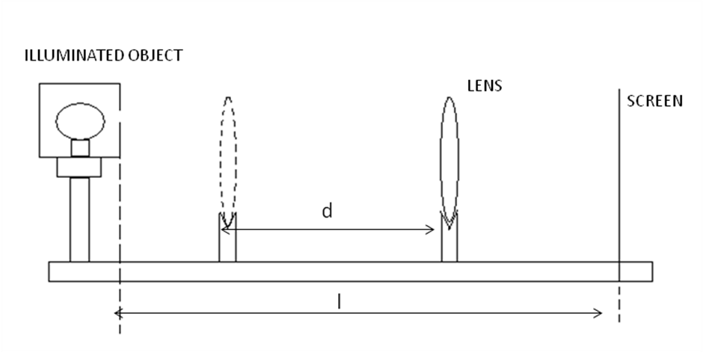
THEORY
Light can travel through vacuum as well as other material such as glasses, air and water. The atoms of a material absorb, reemit or scatter the light. Therefore the speed of light in any material is slower than in vacuum and the speed of light depends on the nature of the material. Refraction is the change in the direction of light ray when it travels through different materials. The index of refraction of a material describes the extent to which the speed of the light in a medium differs from that of vacuum. Lenses are optical instruments made from transparent materials that refract light. They refract light such that the image of the source of light is formed. An object at infinity which is centred on the principal axis of a converging lens produces parallel rays to the principal axis which eventually converge at the focal point of the lens after passing through the lens. A converging lens has a curved surface with a thickened centre unlike a diverging lens. The distance between the focal point and the lens is the focal length, f. It is assumed that the lens is thin as compared to such that it makes no difference whether is measured between the focal point and either surface of the lens or the centre of the lens. The converging lens can form both real and virtual images depending on the position of the object from the lens. When an object is located at a distance from the lens greater than twice the focal length, the image is small, real and inverted than the object. An object located a distance from the lens that is between the focal length and the twice the focal length, the image is real inverted and larger than the object. An object within f produces virtual, upright and larger image as compared to the object. The refractive power of a lens is the reciprocal of the focal length in metres.
Consider an illuminated object placed in front of a screen as shown below. At position B closer to the screen, the lens forms a sharp image on the screen. Let the distance from B to the lens be When the lens is shifted to position A, where the lens is closer to the illuminated than to the screen, another sharp image is formed on the screen. Let that position be labelled as A. Then, the distance from B to the screen is labelled. The distance between the illuminated object and the screen is labelled . The displacement of the lens from position A to B is denoted as .

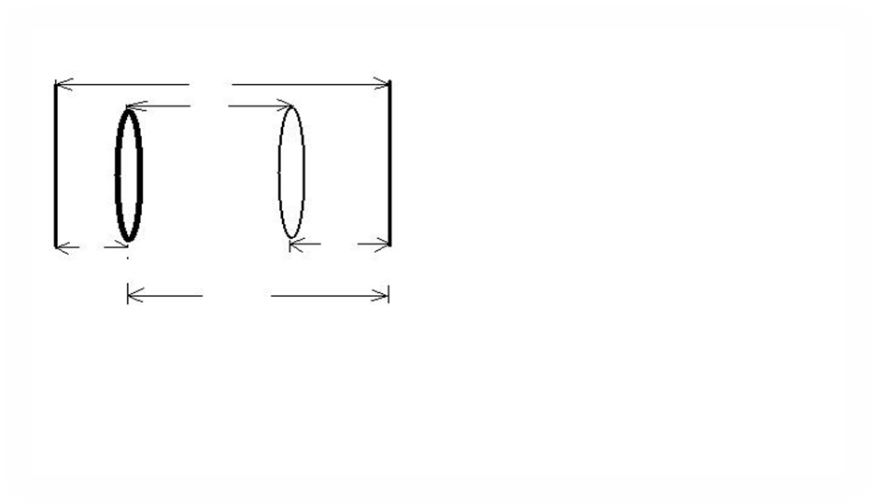 From the diagram above,
x
l
y
y
d
Screen
Illuminated object
Lens
A
B
Adding 1 and 2 →
Subtracting equation 2 from 1
Substitute (3) into (4 ) , we have
+
And. Hence a graph of against has a gradient of 4f which can be used to calculate the focal length.
METHOD
The approximate focal length of a converging lens was determined by focusing the image of a distant object (tree) on a screen. The illuminated object and screen were set more than 4f apart and the separation was measured carefully. Placing the lens nearer the screen, its position was adjusted until a sharp image was focused. The position from the lens to the screen was measured. The lens was moved away from the screen until, at a second position, where a magnified, sharp image was formed on the screen. The difference between the two readings and was calculated as the displacement .The experiment was repeated for four different values of and their corresponding values were determined. The radius of curvature of the lens was calculated and also calculated.
TABLE OF RESULTS (observation)
Focal length of the lens used,=19.2cm=0.192m
Radius of curvature of the lens, r=38.4cm=0.384m r²=0.147m²
90.0 | 0.90 | 0.81 | 60.5 | 27.6 | 32.9 | 0.329 | 0.108 | 0.702
100 | 1.00 | 1.00 | 72.4 | 25.7 | 46.7 | 0.467 | 0.218 | 0.782
110 | 1.10 | 1.21 | 83.6 | 24.8 | 58.8 | 0.588 | 0.346 | 0.864
120 | 1.20 | 1.44 | 94.4 | 23.5 | 70.2 | 0.702 | 0.493 | 0.947
130 | 1.30 | 1.69 | 105.0 | 22.8 | 81.5 | 0.815 | 0.664 | 1.026

graph
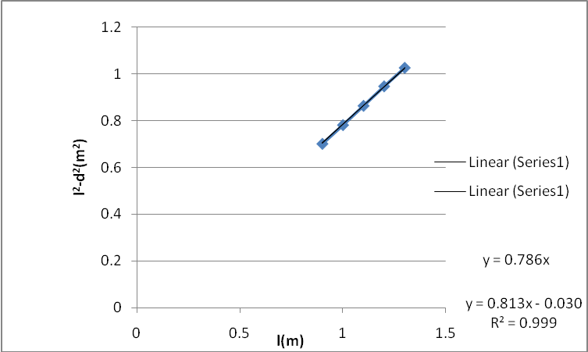
Graph of l²-d²(m²) against l(m)
CALCULATION.
Let s represent the slope
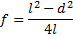
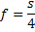
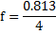
DISCUSSION
This experiment was done to determine the focal length of a converging lens. Five different values of the distance between the screen and the illuminated object were determined and their corresponding x and y values were recorded. From the table it can be seen that the x values increased quantitatively as then distance between the screen and the illuminated object increases. Also ,it can be seen from the results that the x values are higher than their corresponding y values. When the x and y values are critically examined, it can be seen that as the x values increases successively whiles their corresponding y values decreases from one value to another. From the equation of the slope was determined to be 0.813.Comparing the calculated value of the focal length from the graph, thus, to the value of the focal length determined when an object at infinity was focused, that is, , there is a slight difference of 0.008m. The difference in these two values of focal length for the same glass might be due to the fact that the meter rule was not accurately calibrated and therefore gave wrong values for the measurement of the displacement (d), x and y distances. This consequently affected the focal length calculated from the graph and made it slightly different from the. It is possible however that the value of is not also actual focal length of the lens. This is because, the calibrations that were on the rule that was used for the measurements were not so clear and therefore wrong value might have been recorded for the Besides that it is possible that the rule used was not accurately calibrated and resulted in recording wrong measurements. The differences might have resulted from the fact that the measurements were not repeated several times to take their averages. However, comparing and however, the difference is negligible and therefore the experiment can be concluded as been successful.

SOURCES OF ERROR
- Error may be due to the fact that the meter rule was not accurately calibrated and therefore gave wrong values for the measurement of the displacement (d),x and y distances.
- Error may be due to the fact that the lens was not made from a material which is highly transparent so that all the light rays can be refracted perfectly to a single focus to form sharp images. The inability to distinguish very sharp images from somehow distorted ones resulted in measuring wrong positions as where the sharp images were formed.
PRECAUTIONS
- It was ensured that the illuminated object and the screen were separated more than 4f before measuring the distance between them in order to ensure accuracy.
- It was ensured that the illuminated object was bright in order to form clear images to avoid errors.
- It was that all the readings were taking form the eye level in order to avoid parallax error.
- To avoid errors the experiment was repeated to ensure consistency of the values before the values were tabulated.
CONCLUSION
From the experiment, the focal length of the converging lens was found out to be 0.192m=19.2cm by focusing an object at infinity on the screen. However, the focal length was calculated from the graph to be 0.20m=20cm. Averagely, the focal length of the lens can be taken as 0.19.

SM/SMS/08/0011 EXPERIMENT NINE (9)
TITLE: DETERMINATION OF THE FOCAL LENGTH OF A CONVERGING LENS USING OPTICAL PINS.
AIM: To determine the focal length of a converging lens using the no parallax method.
APPARATUS: A convex lens, optical pins, meter rule, lens holder.

DIAGRAM
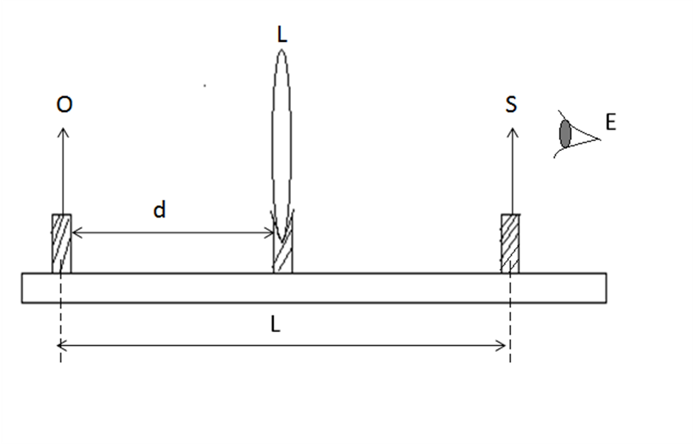
Object pin
Meter Rule
Pin holder
Search Pin
Convex Lens

METHOD
An object pin O, a lens L, and a search pin S were placed on an optical bench. The pins were set in such a way that their tips lay approximately along the axis of the lens. The object pin O was placed at a distance (d) from the lens. The eye E was placed behind the search pin S. The search pin was moved towards or away from the convex lens until there was no parallax between the search pin and the image of the object pin. The distance between the object pin and the search pin (L) was measured and (I-d) was calculated. The experiment was repeated for other values of the object distance d and in each case the values for L-d, (L-d)/d were calculated. The results obtained were tabulated. A graph of (L-d)/d is plotted as ordinate against (L-d) as abscissa. The slope was calculated and the intercept determined from the graph. The reciprocal of the slope was found and its significance indicated.

THEORY
Lenses are optical instruments made of transparent materials that refract light. They refract the light in such a way that the image of the source light is formed. A single point on the principal axis where rays that are near the axis converge after emerging from the lens is called the principal focus. Thus the distance between the principal focus and the centre of the lens is called the focal length. A convex lens is one whose width is small compared to the focal length of the lens. It is known as converging because it causes incident rays parallel to the principal axis to converge at the focal point. A converging lens has a positive focal length.

Image distance=L‒d
Object distance=d but magnification= (image distance/object distance)
Thus where m is the magnification ― ……………….1
From equation of magnification, ―..………………2
But v=image distance=L‒d and f=focal length of the converging lens
Substituting equation 1 into equation 2
= ( ) ‒1…… ………………….. 3
But from equation of straight line y=mx +c
Where m=slope c=intercept on the x-axis y=ordinate and x=abscissa
Comparing equation 3 the equation of the line,
c= ‒1
and slope =1/f
TABLE OF RESULTS

d/cm | l/cm | ( | ()/cm
35.0 | 49.0 | 14.0 | 0.40
30.0 | 45.0 | 15.0 | 0.50
25.0 | 41.7 | 16.7 | 0.67
20.0 | 40.0 | 20.0 | 1.00
15.0 | 45.0 | 30.0 | 2.00

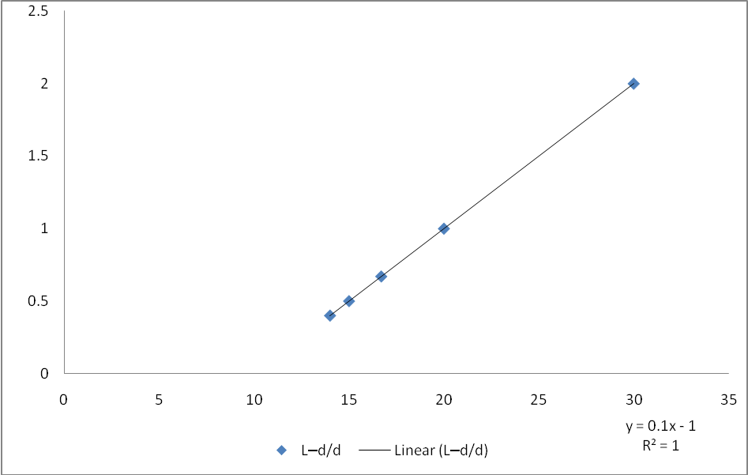

DISCUSSION
The graph has an intercept of -1 on the positive x-axis. The graph is a negative graph with slope (m) =1/f. Hence the focal length of the converging lens is the reciprocal of the slope. From the graph, the slope is 0.1cm hence the reciprocal of the slope (0.1) =10.0cm. This means that the converging lens used in the experiment has a focal length of +10.0cm. The graph L-d/d, which served as ordinate was plotted against L-(image distance) which served as abscissa.
CONCLUSION
From the experiment conducted above, it can be concluded that the approximate focal length of the convex lens used was +10.0cm or + 0.1m

SOURCES OF ERROR
- Error caused may be due to parallax between the search pin and the image of the object pin.
- Error caused may also be due to the scratches on the lens.
PRECAUTIONS
- The lens was cleaned to enhance visibility.
- Error of parallax was avoided by moving the eye from left to right
- It was ensured that the optical pins were set in a way that their tips lay approximately along the axis of the lens.

